Paper 6 Critique
Name: Pakalapati Sri Lakshmi Prasanna Kumar
WSU ID: W845T858
Question 1
Please describe the general approach of IccTA according to Figure 2.
Solution: The steps in the general approach of IccTA are:
First Step: IccTA makes use of Dexpler which transforms the Dalcvick bytecode into Jimple which is a Soot’s internal representation.
Second Step: IccTA extracts the ICC links.
Third Step: It stores all the ICC links and all the other data in the database.
Fourth Step: In this step,
- IccTA modify the Jimple to come directly connect the components to enable data flow analysis.
- In this step the modified version which is of Flow Droid it builds a complete control-flow graph of the Android Application.
Fifth Step: This the last step in which IccTA stores the reported tainted path(leaks) into the database.

Question 2
How to perform taint flow analysis for ICC method startActivity().
Solution: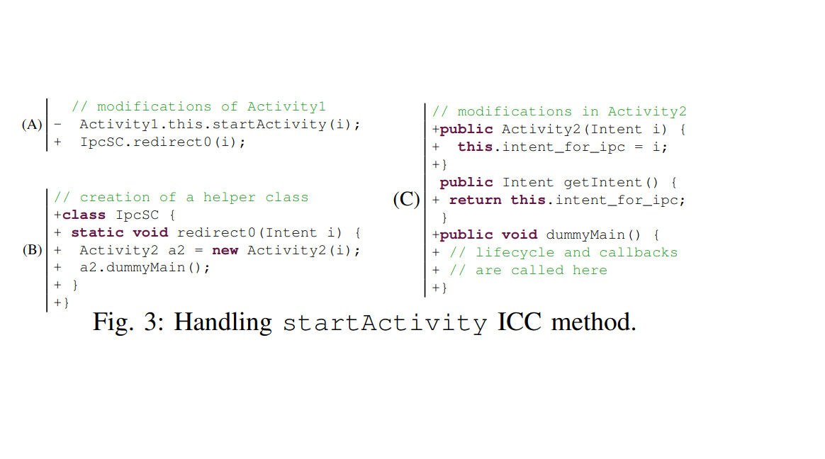

The above codes show how taint analysis is acted in the ICC strategy. In this Activity1 and Activity2 are connected. It makes aide class named IpcSc which acts a connection interfacing the source and objective. Then, at that point, the startActivity is then taken out and supplanted by an assertion calling the generated helper method. In this IccTA produces a constructor which takes a boundary, a spurious fundamental strategy is called to fill all the connected techniques and afterward it abrogates getIntent technique. This plan is callee part. This conduct wherein all the expectation is expressly moving the to the objective part and uses tweaked constructor strategy.
Activity2 accepts the Intent as its boundary and stores it to recently created field. The first technique models the Android framework by returning the item as its given boundary. The aide technique redirect0 develops an object of type Activity2 (the target component) and instates the new item with the Intent given as boundary to the aide strategy. Then, at that point, it calls the dummyMain technique for Activity2.

